**Raspberry Pi:**

The first step in setting up the Raspberry Pi was to choose an operating system for it. Because our group didn’t have experience with the pi before, we decided to use Raspbian Stretch with desktop and recommended software OS, because this version has Chromium, VLC, Python, Geany, PDF and image viewers, and desktop utilities.

In order to install the OS, we had to install on our PC **BalenaEtcher**, which is a software that burn Raspbian OS image to microSD card. After burning the image, we booted for the first time the rasp pi. The next step was to update the operating system, in order to have the latest versions of Python and other features.

The next step was to connect the motion sensor to the Raspberry Pi. To do that, we asked Mr. Thijs Smegen to help as. We provided him a technical design for it:

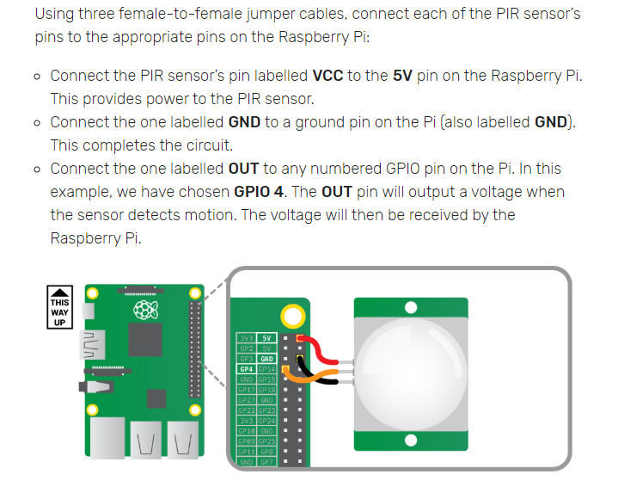

For the camera, we are waiting for Mr. Thijs Smegen to connect our sensor, so we can start writing the script for taking images.

We tried to find solutions for sending images to the server, and we tried doing this by using SAMBA feature, where we tried to share a folder on the network. Another solution that we found was to use an FTP server. But none of those ones were chosen as a final solution. Now we are researching on how we can use Pyhton Flask in order to send the images.